Name(s)_______________________________________________ Period ______ Date _____________

|  |  |  |
| --- | --- | --- |
|  | **Worksheet - Video Guide for “IP Addresses and DNS”** | logo.png |

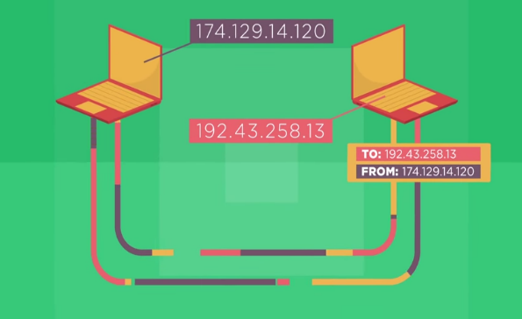

**Overview**

This video features the father of the Internet, Vint Cerf, and Microsoft engineer, Paolo Mejia, addressing the question, “How does data know where to go on the Internet?” They introduce the concepts of Internet Protocol (IP) addresses and the Domain Name System (DNS). In this worksheet, you will use ideas covered in the video as well as search for information on the Internet to answer questions… about the Internet!

**Directions**

1. Watch the video, “IP Addresses and DNS.”
2. Research any additional information required using an Internet search engine.

**Questions**

1. What is a protocol?

1. What is an Internet Protocol (IP) address? How is it organized hierarchically?

1. How many bits are in an IPv4 address?  How many IPv4 addresses does that mean there are?
2. What is the difference between IPv6 and IPv4.  Why do we need IPv6?

1. What is an IP packet?

1. What is the difference between an IP address and an IP Packet?

1. What is the purpose of the Domain Name System (DNS)?

8. How do you clear DNS cache?

9. Explain what DNS poisoning/ spoofing is doing and what are the dangers:

|  |  |  |
| --- | --- | --- |
|  | **The Internet: Packets, Routing and Reliability** | logo.png |

1. How does a packet route to where it is going?
2. How does a router decide the cheapest possible route for packets?
3. What is the function and process that TCP employs?